Name : Zain Khan

Roll:No: 24K-0509

Section : 3A

OOP LAB 1

[TASK #01 by ZAIN KHAN – 0509]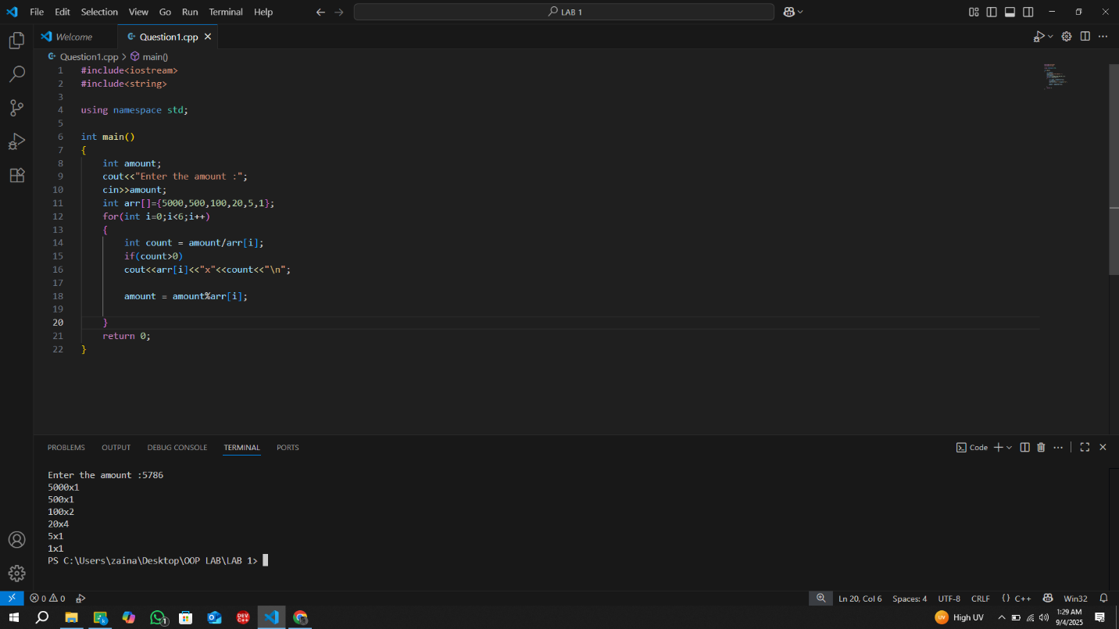

[TASK #02 by ZAIN KHAN – 0509]

[TASK #03 by ZAIN KHAN – 0509]

[TASK #04 by ZAIN KHAN – 0509]

[TASK #05 by ZAIN KHAN – 0509]

